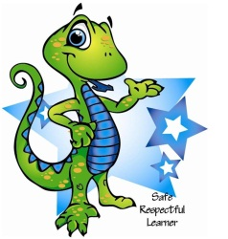
Check in Check Out
Student name: _____________________________________________ Date: _____________________
Key 3 = Great Job! 2 = OK 1 = Try again
 | Safe | Respectful | Learner
Session 1
9.00 – 10.00
Session 2
10.00 – 11.10
Lunch
11.20 – 11.40
Session 3
11.40 – 12.30
Session 4
12.30 – 1.30
Recess
1.30 1.45
Session 5
1.45 – 2.45

Daily Goal: __________________________ My Score: ___________________________

Teacher / Staff signature_______________________________________ Parent Signature ______________________________________________

